Exercise:1
File 1: tt.html
<!DOCTYPE html>
<html>
<head>
<title>Ticket Booking</title>
</head>
<body>
<h1 style="text-align: center; color: red;">Ticket Booking</h1>
<img src="https://t4.ftcdn.net/jpg/13/56/90/09/360_F_1356900978_MvixRtaXsQRbYYlrvW4GNS55bTozyMlT.jpg" alt="Train" width="300">
<p>Read the <a href="https://wikipedia.org" target="_blank">Rules</a> before booking.</p>
<ul>
<li>Bring your ID</li>
<li>No refunds</li>
</ul>
<table border="1">
<tr><th>City</th><th>Price</th></tr>
<tr><td>New York</td><td>$50</td></tr>
</table>
<form action="success.html">
<h3>Book Ticket</h3>
<p>Name: <input type="text" required></p>
<p>City:
<select required>
<option value="">Select</option>
<option>New York</option>
</select>
</p>
<p>Date: <input type="date" required></p>
<p>Tickets: <input type="number" min="1" value="1" required></p>
<button type="submit">Book Now</button>
</form>
</body>
</html>
File 2: sample.html
<!DOCTYPE html>
<html>
<head>
<title>Booking Confirmed</title>
</head>
<body>
<h1 style="text-align: center; color: red;">Booking Confirmed!</h1>
<p>Thank you! Your ticket reservation has been successfully processed.</p>
<h3>Your Next Steps:</h3>
<ul>
<li>Check your email for your digital ticket.</li>
<li>Please arrive 15 minutes before departure.</li>
</ul>
<p><a href="tt.html">Go Back to Booking Page</a></p>
</body>
</html>
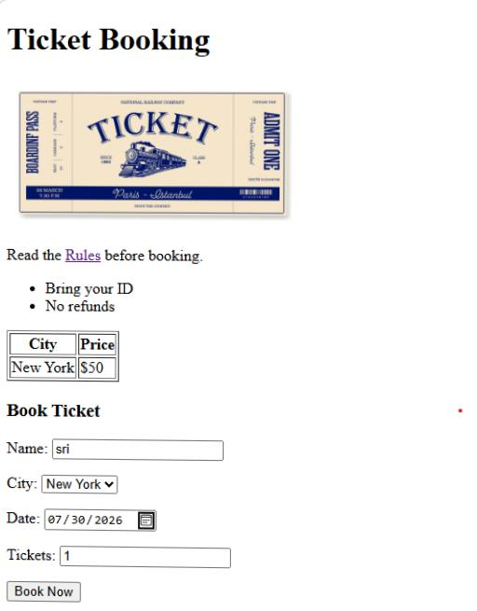
Output:

